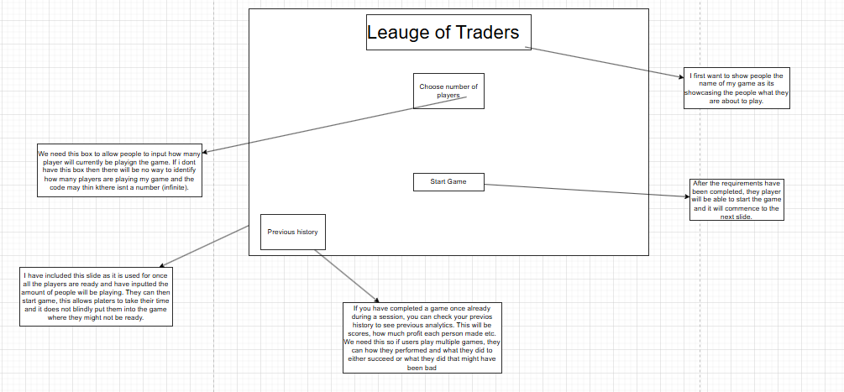
Gui design

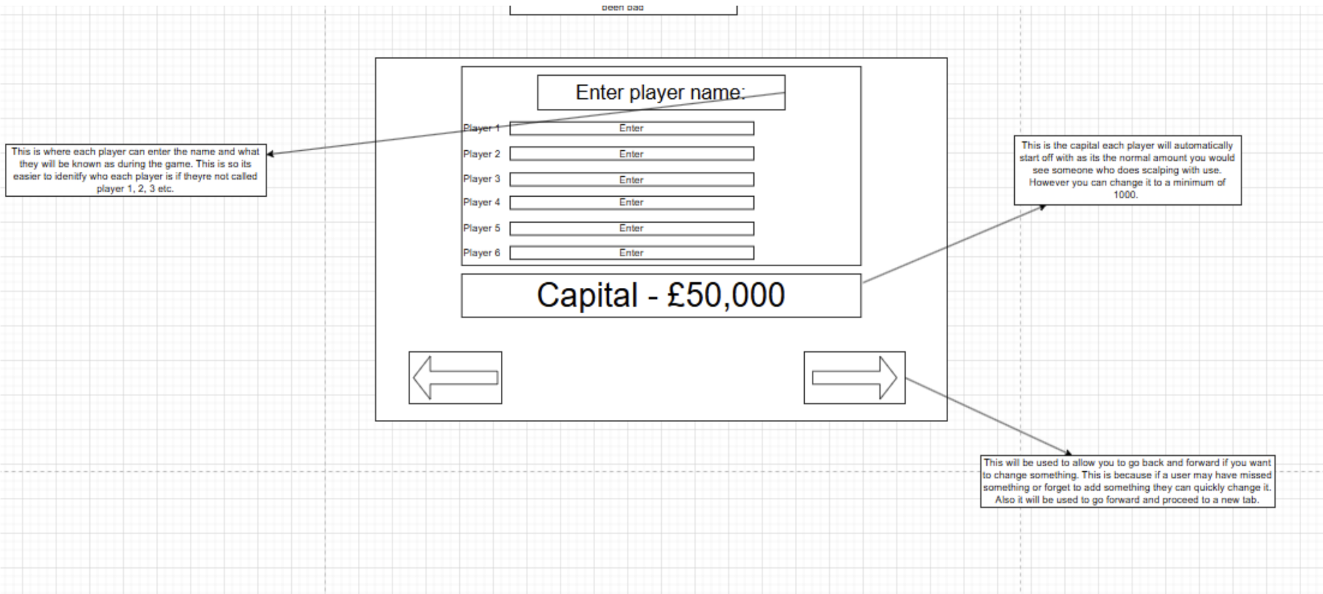

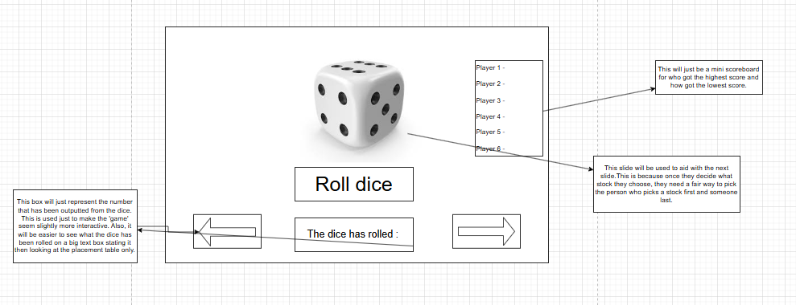
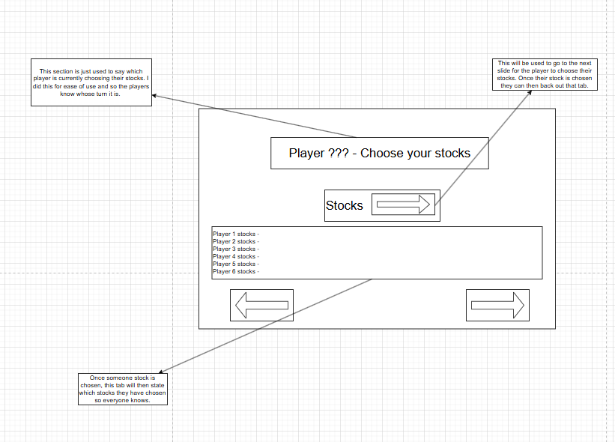
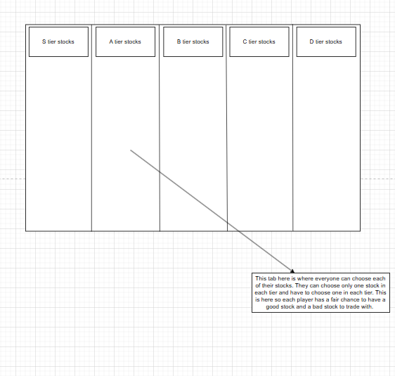
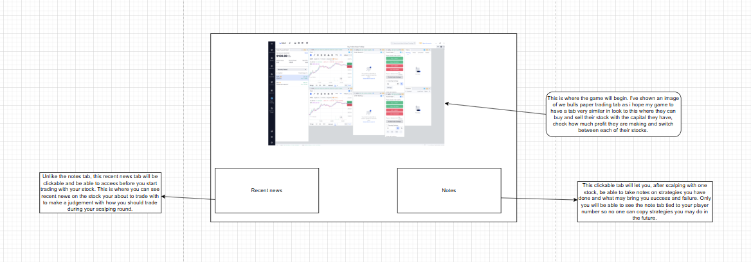
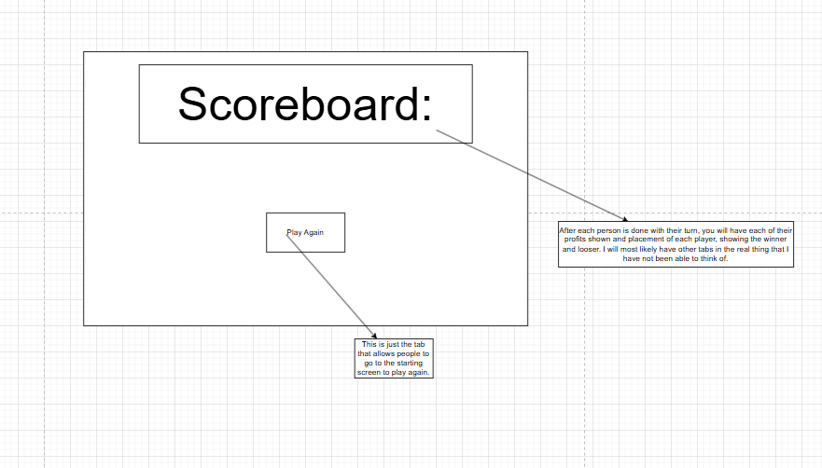

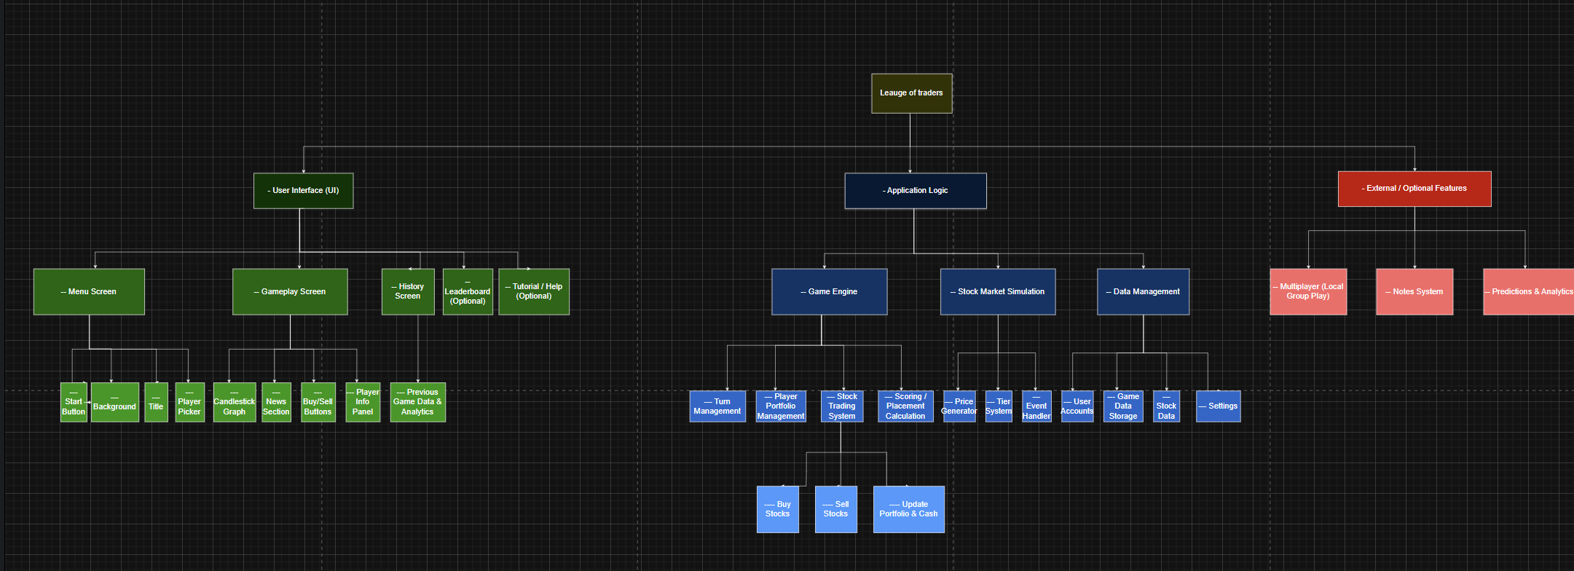

My structure diagram for the game, ‘League of traders’, is split into 3 core thirds. 2 of these thirds contribute to a unique layer of my game to bring a more dynamic and interactive experience.

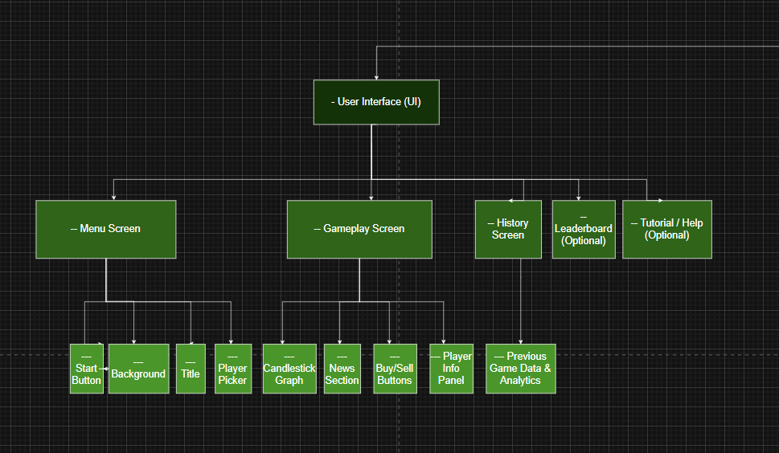

The left most third is centred towards the Ui of my game. The UI, also known as the user interface, is used to allow a human to interact with a computer. You can consider it the design of my game and what each part of my game will look like.

We first have our menu screen which allows you to start the game. This menu screen will be split up into 3 key components. My start button which basically lets you go into the next part of your game. Then we have the background of our menu screen which will be tied to the general purpose of my game. Like I stock trading graph, this is because it gives the user an understanding of what the game will look like. Then we will have a title screen which will be the name of my game, league of traders, this is essential for any game as it makes your screen filled out with more key information. I added a main menu screen, so the users do not have to go straight into the game but take their time to do things before they are all ready.

Then we have other parts such as the gameplay screen. One of the core features of this section will be the candle stick graph, this is because you use this graph to see how the stocks you used are looking. To see if it’s better to buy or sell and needed to know how your stocks are interacting in the game. Furthermore, before the game starts, you will have a news section where you can see how your stocks have been acting with past analytic data of them represented by articles, percentages etc. Finally, you will have a buy or sell button to buy or sell your stocks and a player info panel showing the profits each player made during their turn.

Finally, I will have a history screen, which will be accessible after one game has been completed showing previous game data of how each player played and analytics indicated clear mathematical data on the very key parts of a game. A leaderboard of each game that has been played with that specific group to indicate the winners and looser of each game. Then a help option that will let you, if you are struggling, seek help to read how the game works.

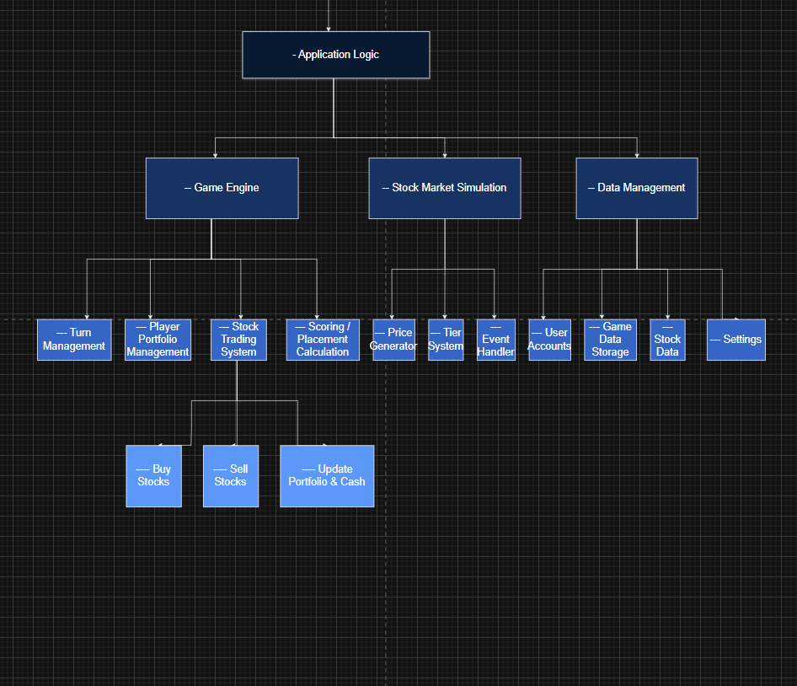

The 2nd third of my structure diagram showcases the application logic side of my game. This is the backbone of my game which will take over all core mechanics, trade algorithms, player interactions and in game system. To show case this I have first showed the 3-core feature that make up the application logic.

It will have the game engine which brings the turn management system, player portfolio management, stock trading system and placement calculation to life. Our stock trading system will have features such as buy stocks, sell stocks and updating your portfolio.

A stock management system that allows you to generate the pieces of each stock, the tier system which places each stock in a tier based off its volatility, cost, and many other features to base it off. Then finally an event handler.

We finally have the data management section which holds the data of each of our users account Store all the analytics of the game data and our stock data. Finally the settings in which our users can adjust to fit their group’s needs.
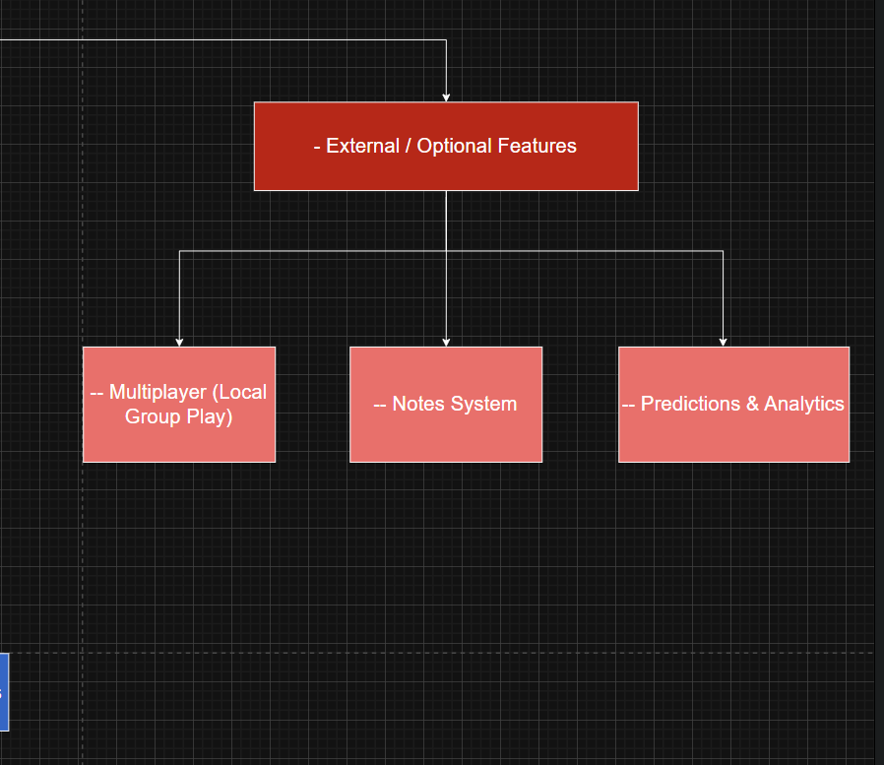

Finally, I third section will contain all the optional features I may add to my game if I ever get the time to. The 3 main things I would like to add is a multiplayer version were the players can play all on different computers. A note system where each player can take notes on the strategies they performed on the game to do better or what they can do to do better. Finally, a prediction section which will possibly go into the tier system to add another layer to it showcasing predictions for what stocks are likely to rise in the future and fall.

Development plan:

Before I design the full game, interface or adding all gameplay options, I should try to successfully implement a basic prototype of the game which represent my core fundamental mechanics. So, for this, I should have my gameplay involve generating a visual representation of stocks and player actions, testing the real time effects of trades and portfolio changes.

Features/functionality to implement:

. A window showcasing the key gameplay actions, which can be changed by players. Players are able to interact with.
. Basic actions players can do such as buying or selling stocks. Being able to pick their stocks. Either make or looser profit and update their capital showcasing their entire portfolio. Showing how it started and how it ended.
. I will have visual feedback on the stock prices, represented as a candlestick graph showcasing real time update from the stock market.
. I will be ensuring the capital and stock portfolio update correctly and as fast as possible during each trade and is clearly showcased to the player currently playing.

Stakeholders will be looking at the visual clarity and speed of each update of shifts within the stock trading market tied to their stock. If the speed of the candle stick graph is too fast, the interface may need to adjust the speed of it to fit in line with beginner traders who may not be used to high volatility stocks such as tesla, apple, NVidia etc.

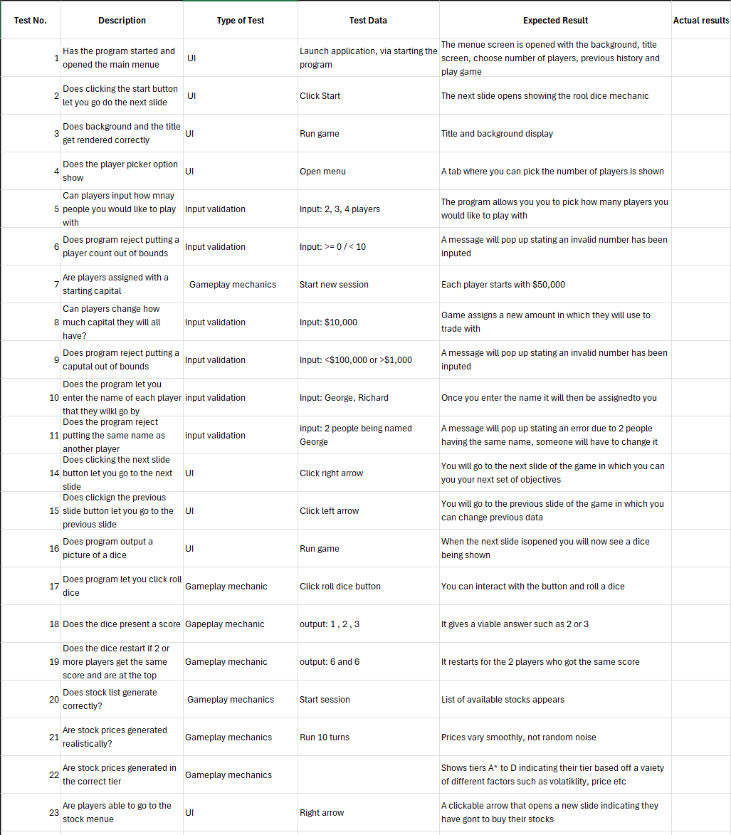
This prototype serves as the foundation of my full game. Allowing all my testers to verify its features stripped down to its basic form. This is before adding other basic features such as my menu, tier system, news tab etc. The test plan showcased is building on the prototype, looking at initial setup and interface checks. Then on each of the players actions, stock interactions and finally updates to their portfolio.

